Instructions for monitoring your blood pressure from home

- Avoid caffeine, tobacco and vigorous exercise prior to preforming blood pressure
- Empty your bladder before taking your blood pressure
- Sit quietly for 5 minutes before preforming your blood pressure
- Your legs should be uncrossed, feet flat on the floor, back supported and arm at heart level
- Blood pressure cuff is placed on your bare skin at the midpoint of your upper arm
- Avoid talking, active listening and stimulating activities while taking your blood pressure
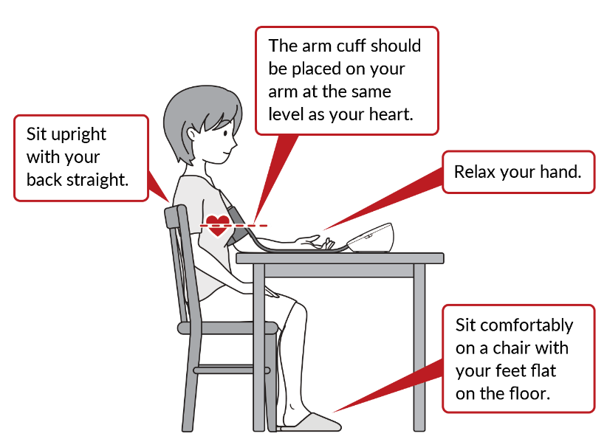

Healthcare.omron.co.jp
Check your blood pressure twice in the morning and twice in the evening. Wait at least one minute between readings. It is important to check your blood pressure in each arm periodically.

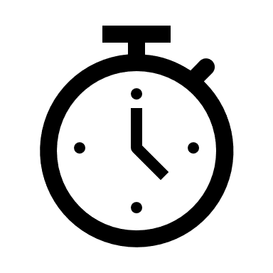
TIPS:
Set a daily alarm to remind you to take your blood pressure
Record your blood pressure readings in a log book
My Blood Pressure Log Book
Please contact the office if your blood pressure is:
Higher than: ____________________________
OR
Less than: _____________________________
Call 911 for emergency blood pressure ________________________________________________________

Time of Day | Blood Pressure | Symptoms
Time of Day | Blood Pressure | Symptoms

